2. You are given two integer arrays nums1 and nums2 of sizes n and m, respectively.
Calculate the following values: answer1 : the number of indices i such that nums1[i]
exists in nums2. answer2 : the number of indices i such that nums2[i] exists in nums1
Return [answer1,answer2].
Example 1:
Input: nums1 = [2,3,2], nums2 = [1,2]
Output: [2,1]
Explanation:
Example 2:
Input: nums1 = [4,3,2,3,1], nums2 = [2,2,5,2,3,6]
Output: [3,4]
Explanation:
The elements at indices 1, 2, and 3 in nums1 exist in nums2 as well. So answer1 is 3.
The elements at indices 0, 1, 3, and 4 in nums2 exist in nums1. So answer2 is 4.
Input:
def find_intersection_values(nums1, nums2):
answer1 = 0
answer2 = 0

for num in nums1:
if num in nums2:
answer1 += 1

for num in nums2:
if num in nums1:
answer2 += 1

return [answer1, answer2]

n = int(input("Enter the size of nums1: "))
nums1 = []

print("Enter the elements of nums1:")
for i in range(n):
nums1.append(int(input()))

m = int(input("Enter the size of nums2: "))
nums2 = []

print("Enter the elements of nums2:")
for i in range(m):
nums2.append(int(input()))

result = find_intersection_values(nums1, nums2)

print("Output:", result)
Example 1 :
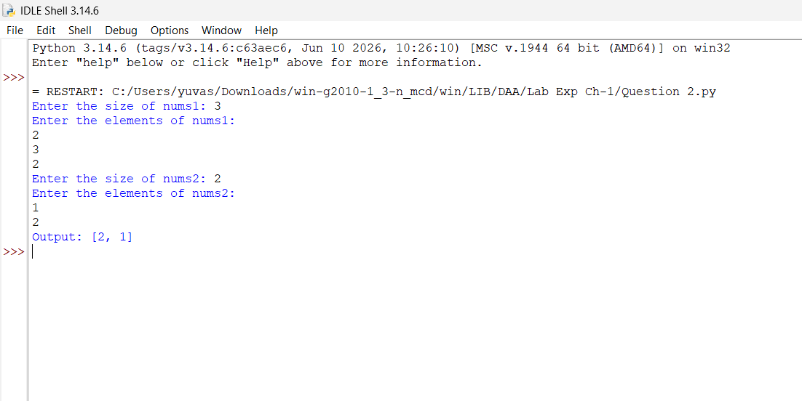

Example 2:
